**Test Plan: Motor Insurance Calculator**

The program will have two main pieces of data that need tested:

Data being assigned to the Driver object, as this must be validated to return a pass or fail for the policy application. The validations are as follows:

Start date of the policy cannot be before today.

Driver cannot be outside 21-75 years old.

User should also not be able to choose a date in the future for a birthday.

A driver cannot have more than 2 claims.

The policy cannot have more than 3 claims.

User should not be allowed to input an incomplete form, as driver should not have unassigned values.

The change to premium that is calculated depended on certain rules, these rules are as follows:

Base value is 500.

If a driver is a chauffeur, increase by 10%.

If a driver is an accountant, decreases by 10%.

If the youngest driver on the policy is between 21-25 at the start date of the policy, increase by 20%.

If the youngest driver on the policy is between 26-75 at the start date of the policy, decrease by 10%.

If a claim associated with a driver is within 1 year of the start date of the policy, increase by 20%.

If a claim associated with a driver is within 2-5 year of the start date of the policy, increase by 10%.

**Manual Testing**

**Test 1**

Inputting a policy start date in the past

Expected result: Input Denied

Actual Result:

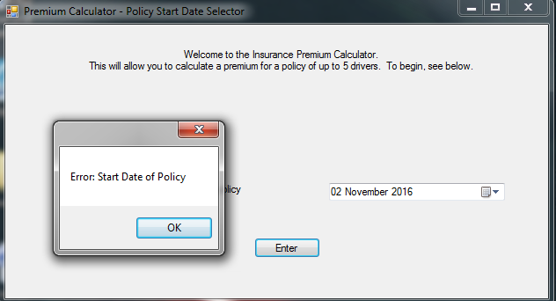

Conclusion - Pass

**Test 2**

Entering an incomplete form

Expected result: Input Denied

Actual Result:

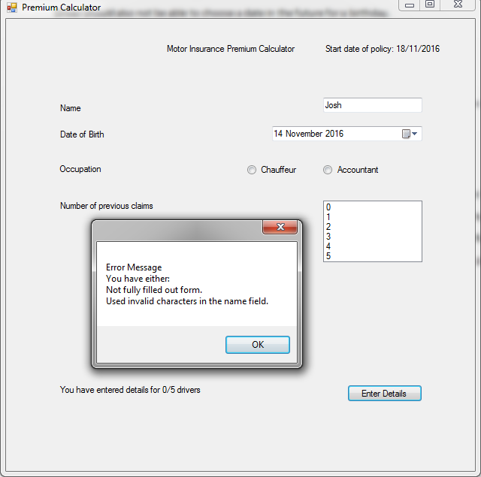

Conclusion - Pass

**Test 3**

Entering invalid characters into the name field

Expected Result: Input Denied

Actual Result:

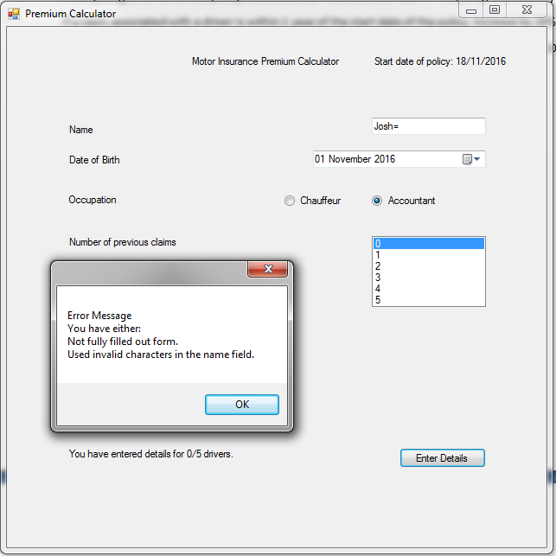

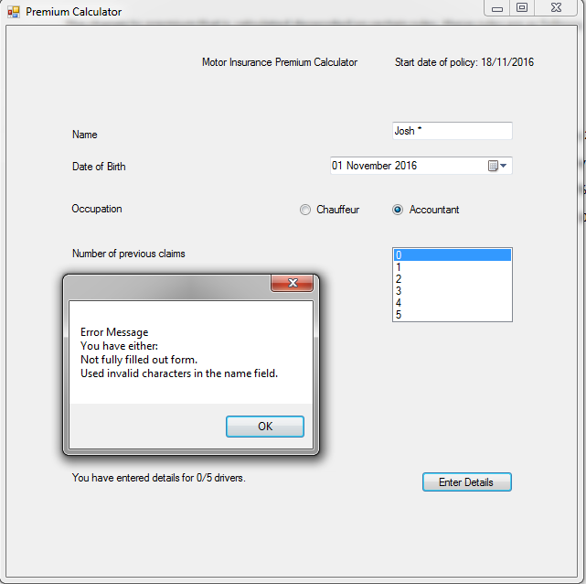

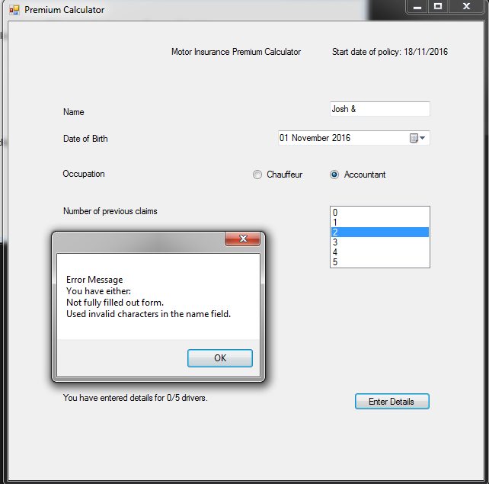

Conclusion - Pass

**Test 4**

Entering an date of birth in the future

Expected result: Input Denied

Actual Result:

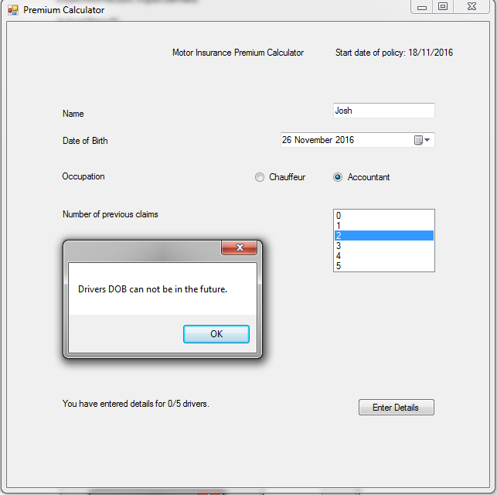

Conclusion - Pass

**Test 5**

Successfully entering a filled form

Expected result: Input Allowed, driver count increments, Premium button appears, fields reset

Actual Result:

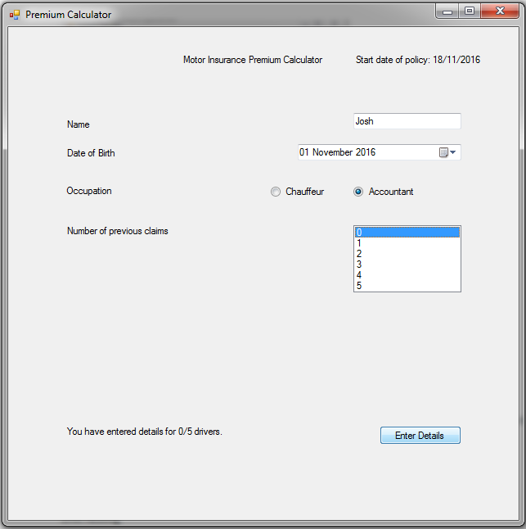

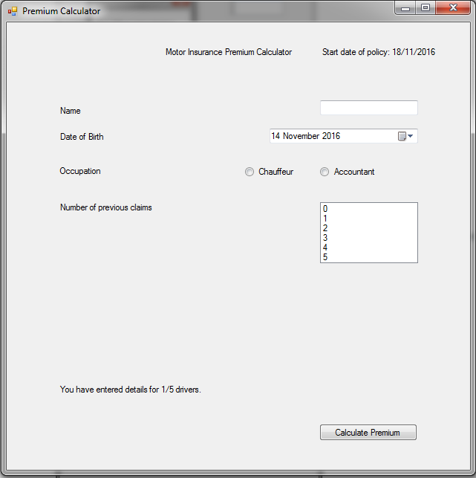

Conclusion -Pass

**Test 6**

Successfully filling policy to maximum drivers

Expected result: Input Allowed, driver count increments, Premium button appears, fields reset, Enter Button no longer appears

Actual Result:

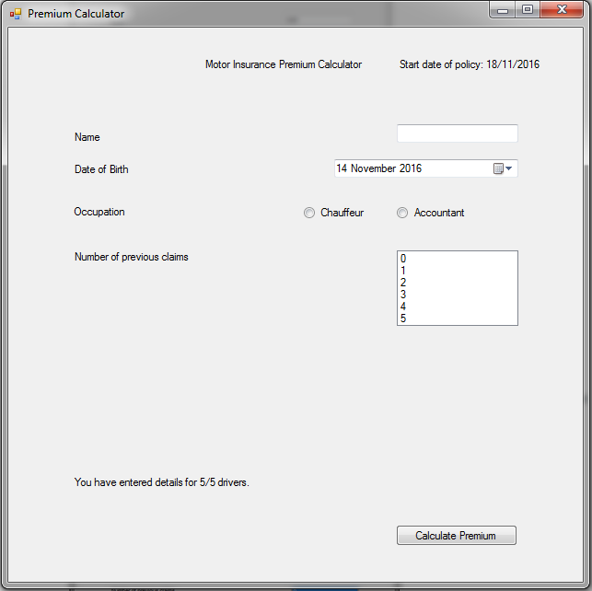

Conclusion - Pass

**Test 7**

Press the calculate premium button with drivers that pass the checks

Expected result: Will a premium calculation

Actual Result:

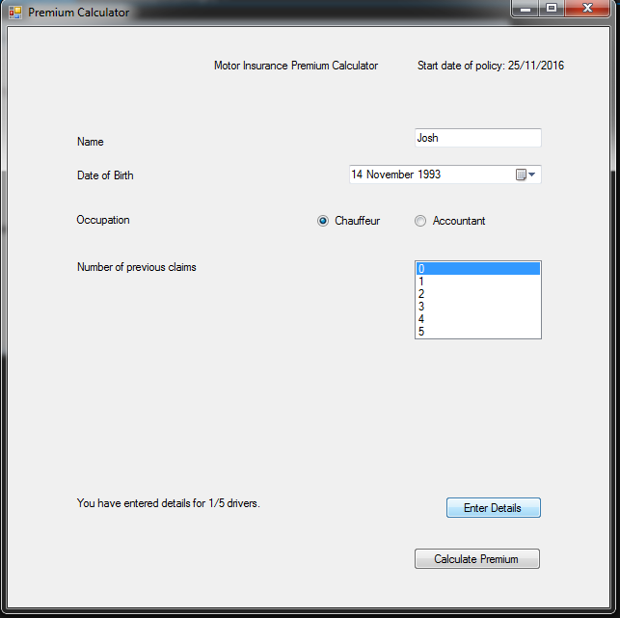

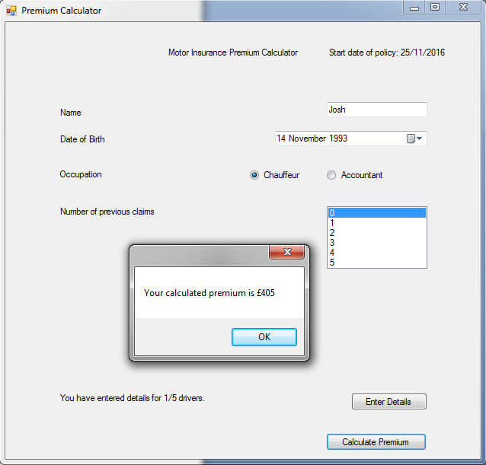

Conclusion - Pass

**Test 8**

Press the calculate premium button with drivers that fail the checks

Expected result: Will display a decline message with name of driver and reasons for decline

Actual Result:

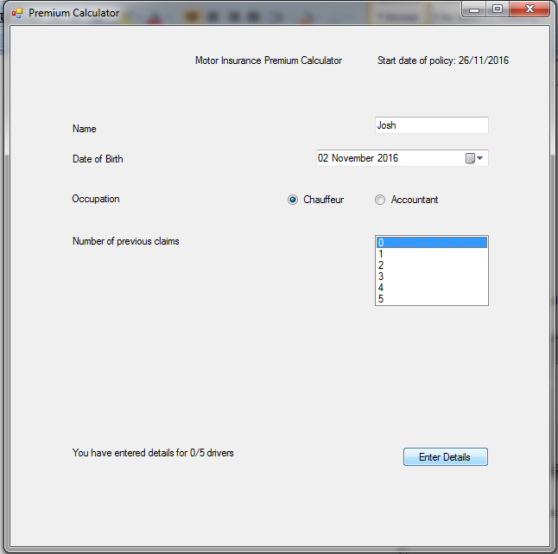

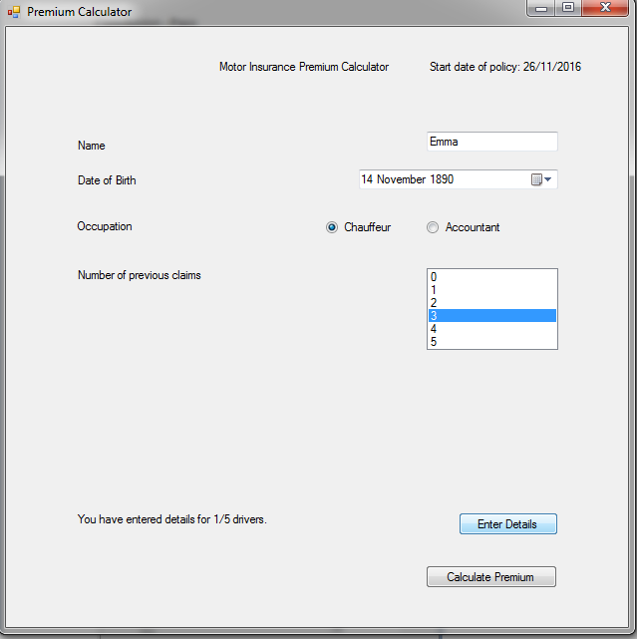

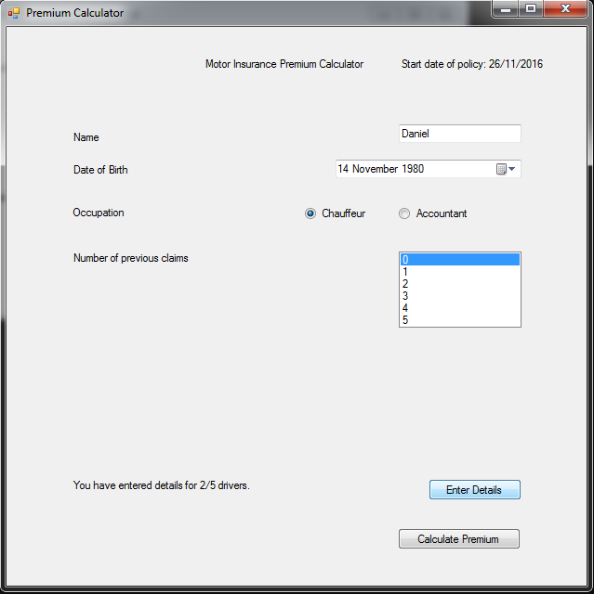

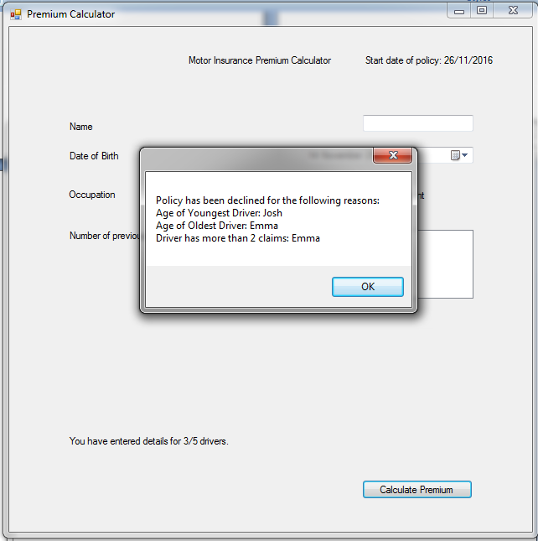

Conclusion - Pass

**Test 9**

Press the calculate premium button with too many claims overall (With another driver error)

Expected result: Will display a decline message

Actual Result:

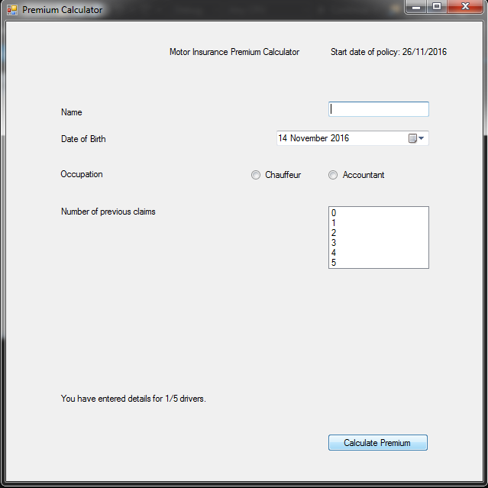

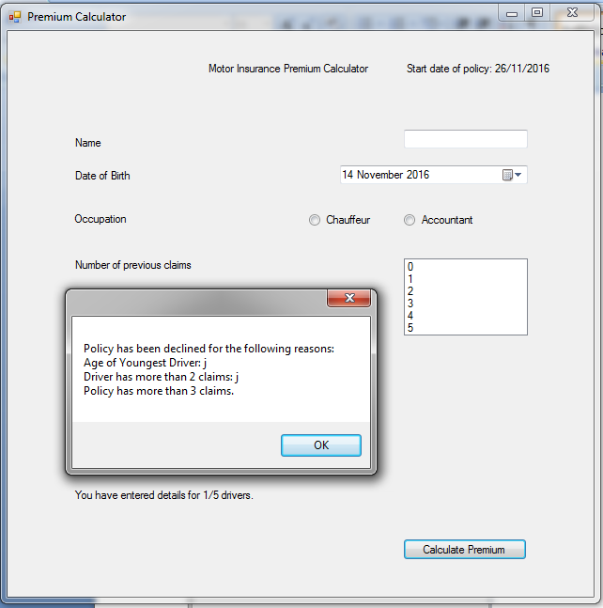

Conclusion - Pass

**Test 10**

Enter a driver with claims

Expected result: Prompt appears telling driver to input the number of claims, input for claim dates appear and input for driver details disappear.

Actual Result:

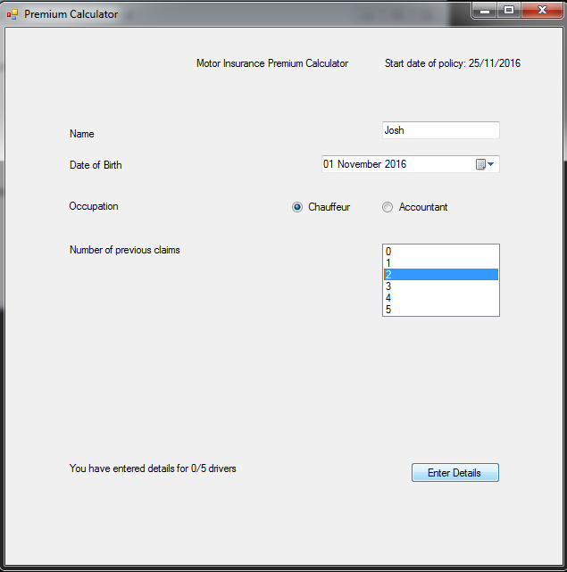

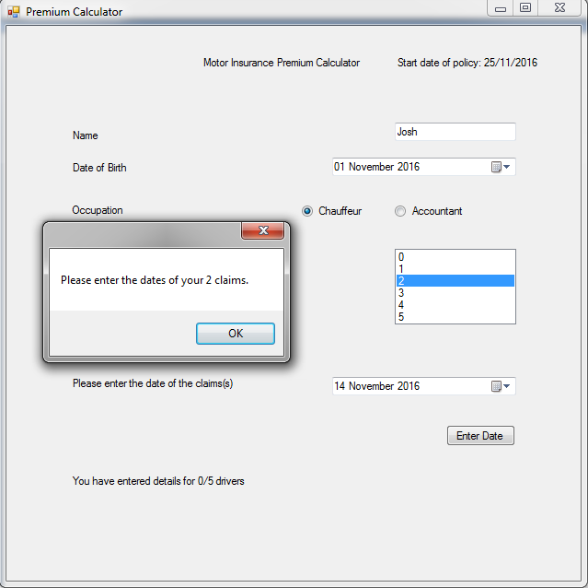

Conclusion - Pass

**Test 11**

Successfully entering claims

Expected result: Prompt appears alerting user to having 0 claims left and removes claim data input, fields reset and normal input appears

Actual Result:

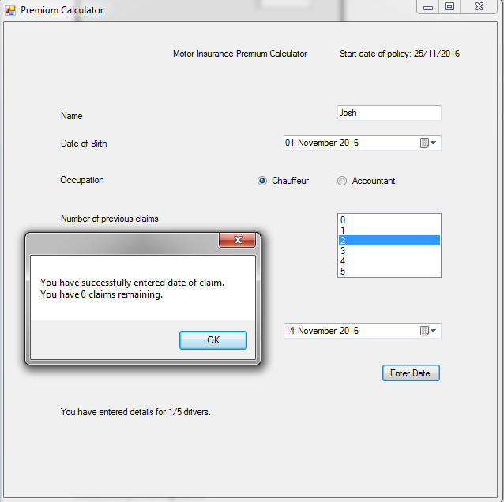

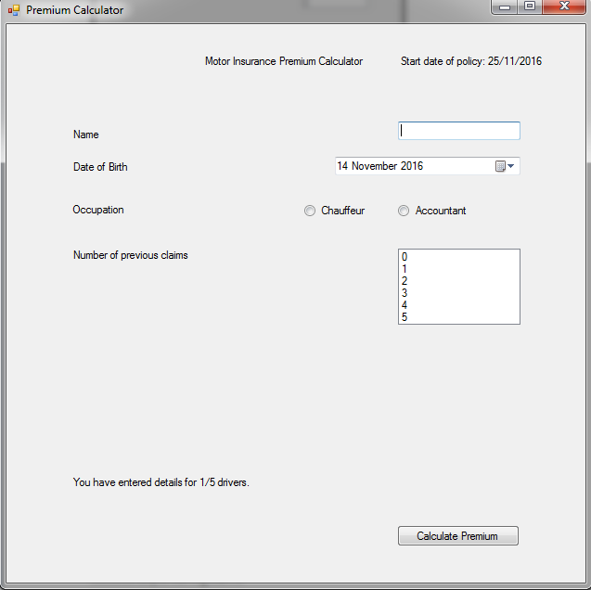

Conclusion - Pass

**Test 12**

Trying to input claim date in the future

Expected result: Declines input with error message and resets date

Actual Result:

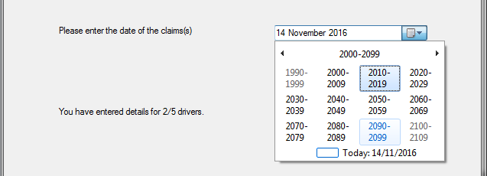

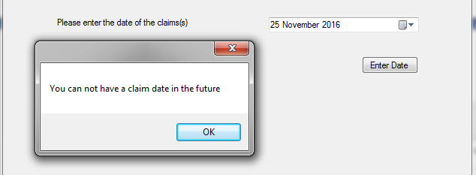

Conclusion - Pass

**Test 13**

Input of a valid claim date

Expected result: Accepts date, tells driver how many more claims they need to enter

Actual Result:

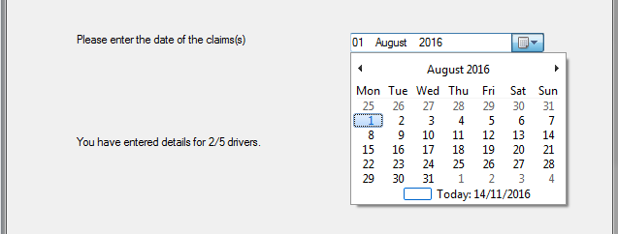

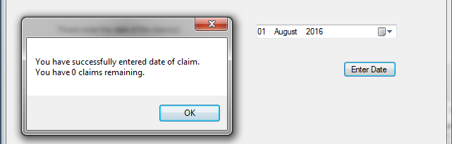

Conclusion - Pass

**Unit Testing**

**Test 1**

Add driver method assigns driver to the driver list

Result:

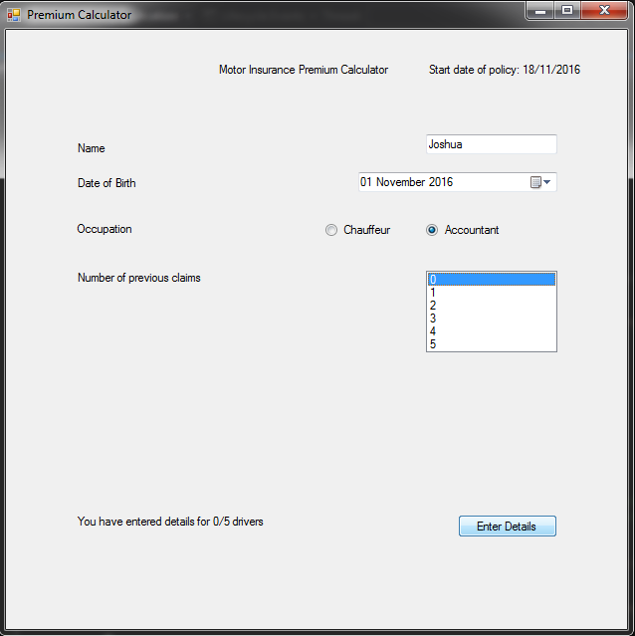

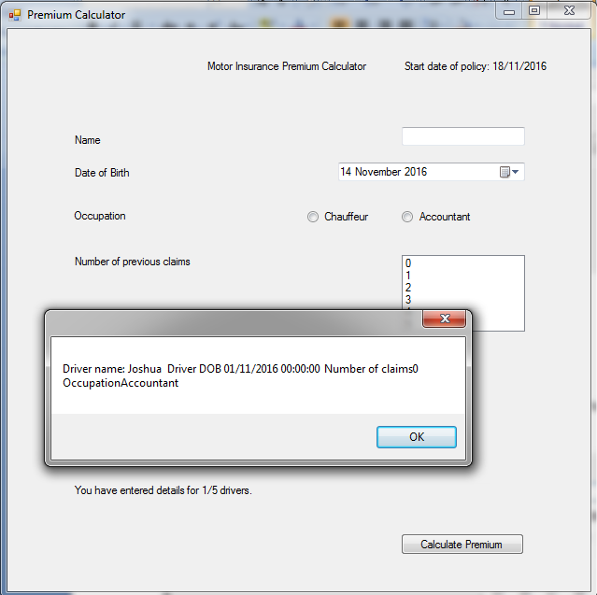

Conclusion - Pass

**Test 2**

Calculate Age

Input - 25/10/1994 with start date 15/11/2016

Expected Output - 22

Result:

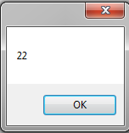

Conclusion - Pass

**Test 3**

Calculate Youngest Driver

Input - Daniel DOB 25/10/1990, Josh DOB 25/10/1996, start date 15/11/2016

Expected output - Youngest Driver: Josh

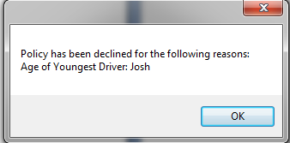

**Test 4**

Premium calculation - Accountant

Expected output - 450

Result:

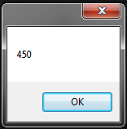

Conclusion - Pass

**Test 5**

Premium calculation - Chauffeur

Expected output - 550

Result:

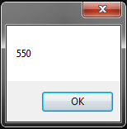

Conclusion - Pass

**Test 6**

Premium calculation - Youngest Driver between 21-25

Expected output - 600

Result:

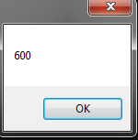

Conclusion - Pass

**Test 7**

Premium calculation - Youngest Driver between 26-75

Expected output - 450

Result:



Conclusion - Pass

**Test 6**

Premium calculation - Claim date within 1 year

Expected output - 600

Result:

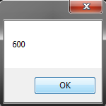

Conclusion - Pass

**Test 8**

Premium calculation - Claim date within 2-5 years

Expected output - 550

Result:

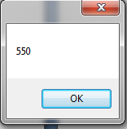

Conclusion - Pass

**Test 9**

Premium calculation - Claim date over 5 years

Expected output - 500

Result:

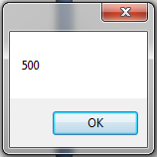

Conclusion - Pass